8.2 DFD Level 2- Specimen & Lab Worklist

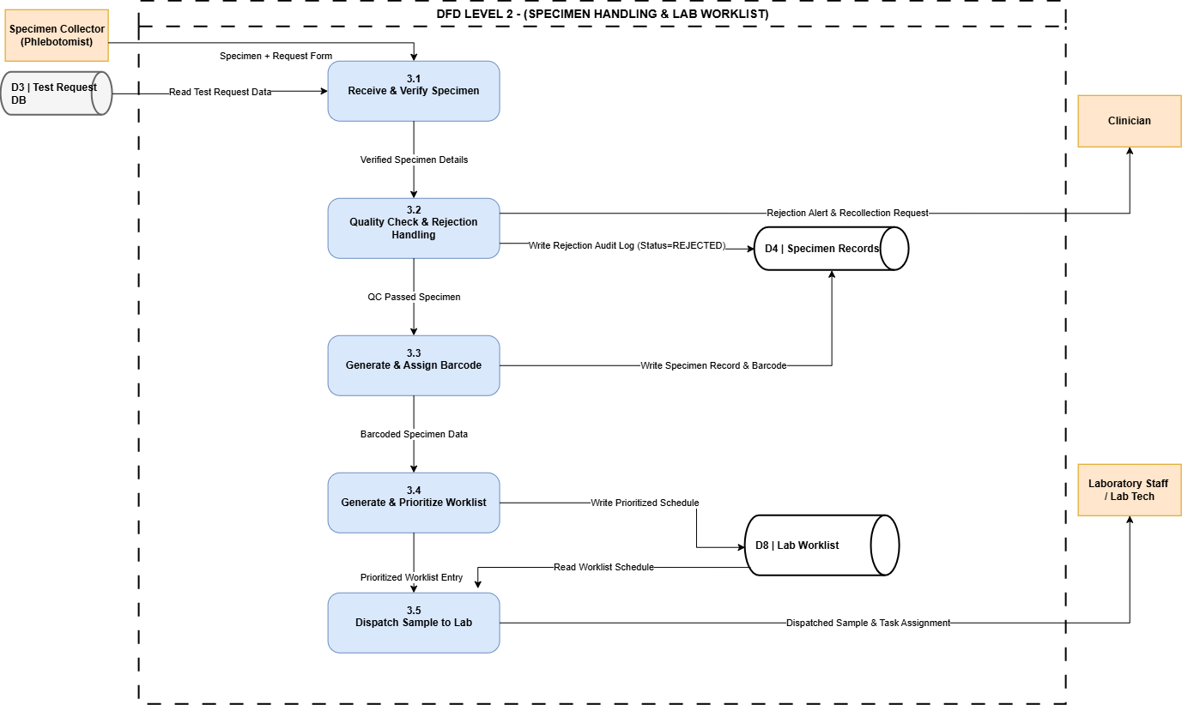

FR MAPPING TABLE
Process ID | Process Name | Mapped FR ID | Functional Requirement Description | Data Stores Involved | Inputs & Outputs
3.1 | Receive & Verify Specimen | FR17 & FR22 | FR17: Specimen Registration against test request.  FR22: Specimen Receipt confirmation, condition, and receiving staff logging. | D3: Test Request DB | In: Specimen + Request Form  Out: Verified Specimen Details
3.2 | Quality Check & Rejection Handling | FR23 & FR24 | FR23: Specimen Acceptance/Rejection and recording rejection reasons.  FR24: Specimen Recollection Request and clinician notification. | D4: Specimen Records | In: Verified Specimen Details  Out: Rejection Alert (to Clinician), QC Passed Specimen
3.3 | Generate & Assign Barcode | FR18 & FR19 | FR18: Barcode Generation of a unique ID for each specimen.  FR19: Specimen Label Printing containing patient/specimen info. | D4: Specimen Records | In: QC Passed Specimen  Out: Barcoded Specimen Data
3.4 | Generate & Prioritize Worklist | FR25 | FR25: Laboratory Worklist Generation based on test type, priority, department, and specimen status. | D8: Lab Worklist | In: Barcoded Specimen Data  Out: Write Prioritized Schedule
3.5 | Dispatch Sample to Lab | FR21 & FR26 | FR21: Specimen Tracking throughout the lab testing lifecycle.  FR26: Test Assignment and dispatch to laboratory staff. | D8: Lab Worklist | In: Prioritized Worklist Entry  Out: Dispatched Sample & Task Assignment (to Lab Tech)

